AI ASSISTED CODING

**ASSIGNMENT – 2.3**

**MD ZIAUDDIN**

**2403A51271**

Task Description#1

* Use Google Gemini in Colab to write a function that reads a CSV file and calculates mean, min, max.

prompt –

write a function that reads a CSV file and calculates mean, min, max Code –

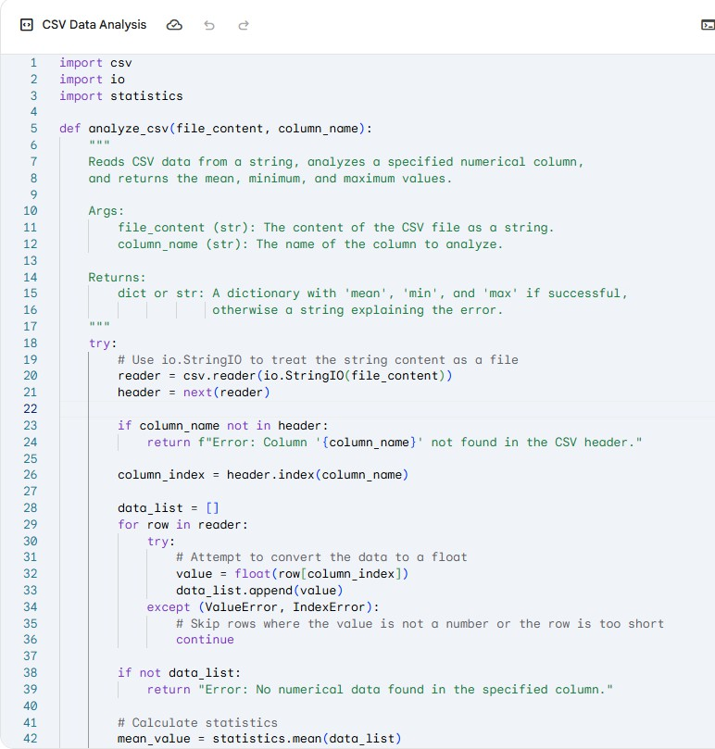

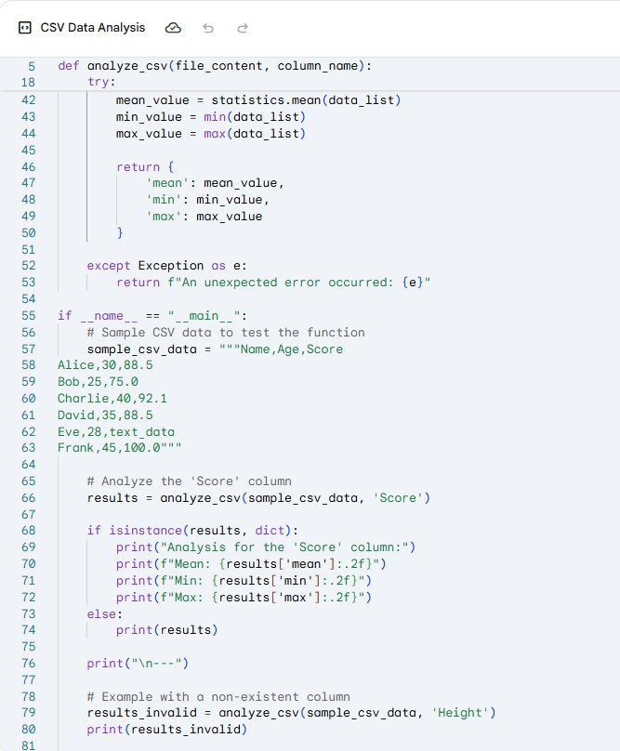

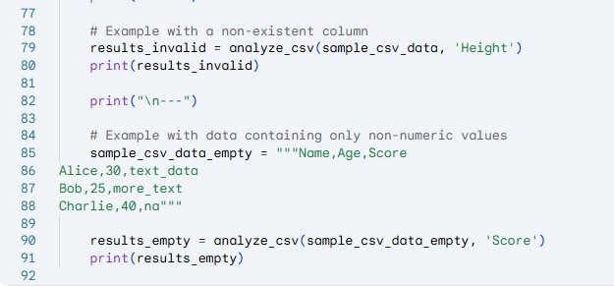

Output –

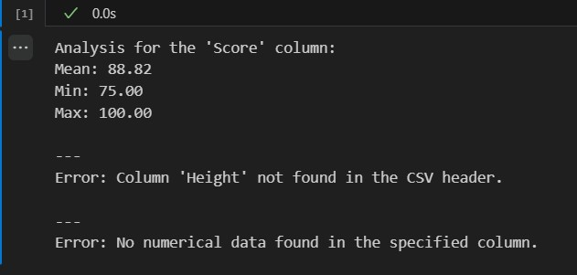

Task Description#2

* Compare Gemini and Copilot outputs for a palindrome check function. prompt –

generate a palindrome check function.

Code by gemini –

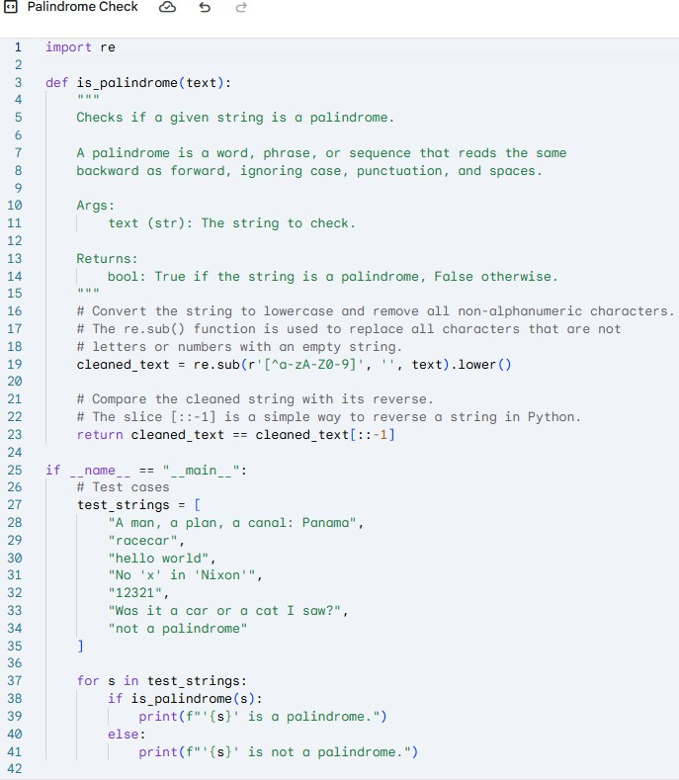

Output –

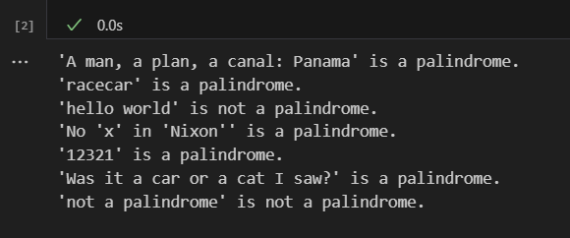

Code by copilot–

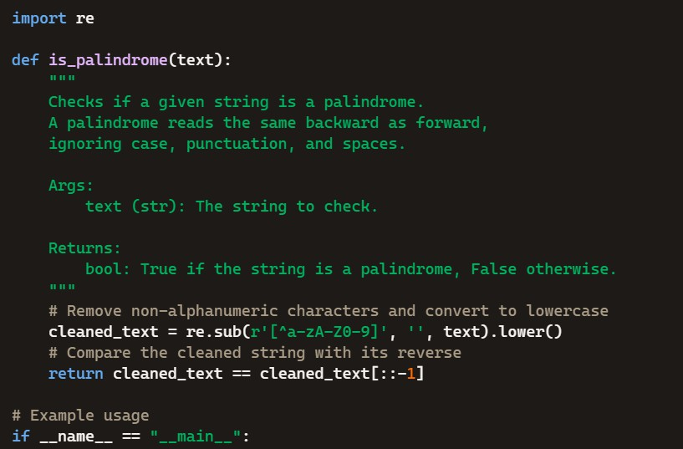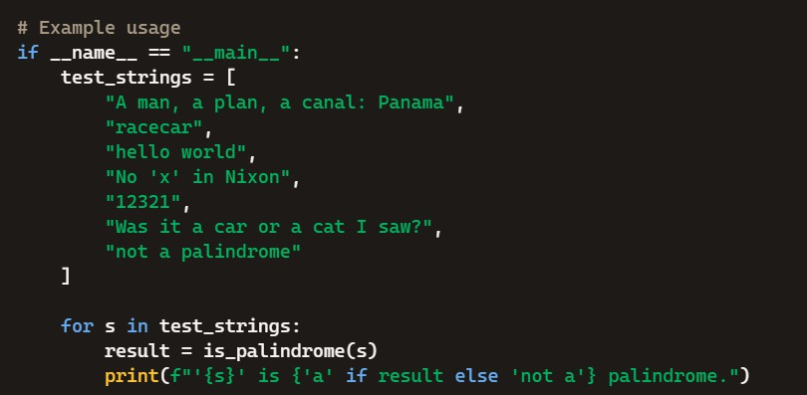

Output –

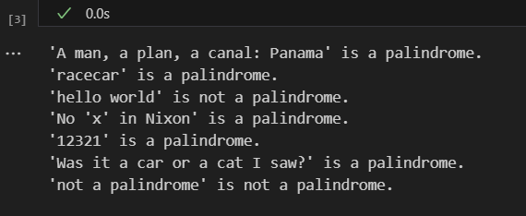

Code given by copilot is simpler than compared to gemini but both the outcomes are exactly the same

Task Description#3

* Ask Gemini to explain a Python function (to calculate area of various shapes) line by line. prompt –

explain a Python function (to calculate area of various shapes) line by line.

Code by gemini–

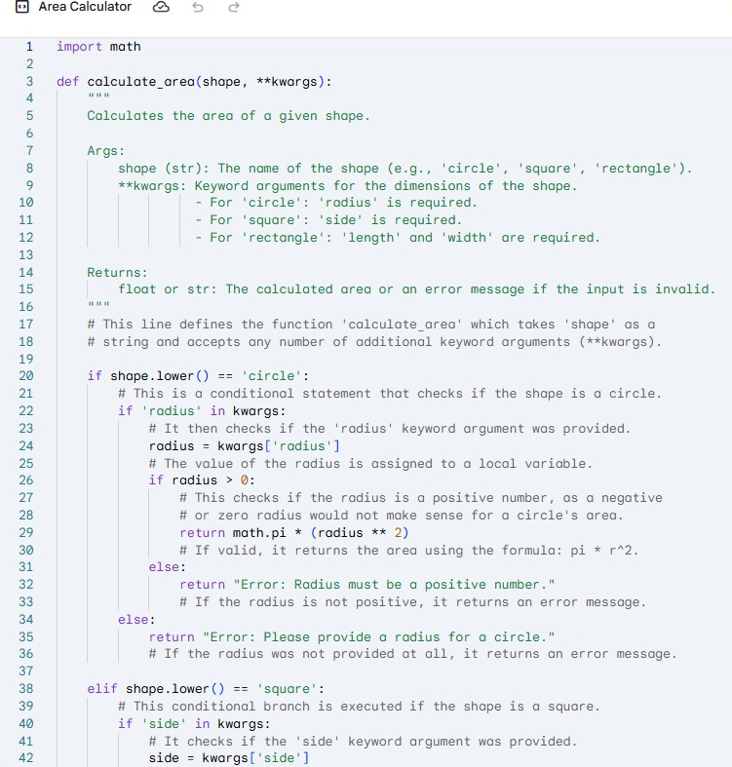

Output –

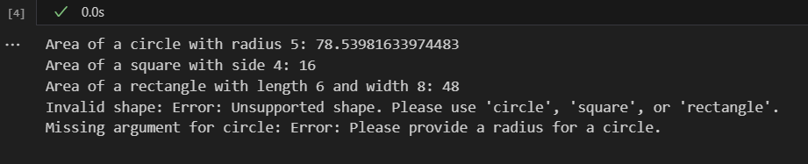

Code by copilot –

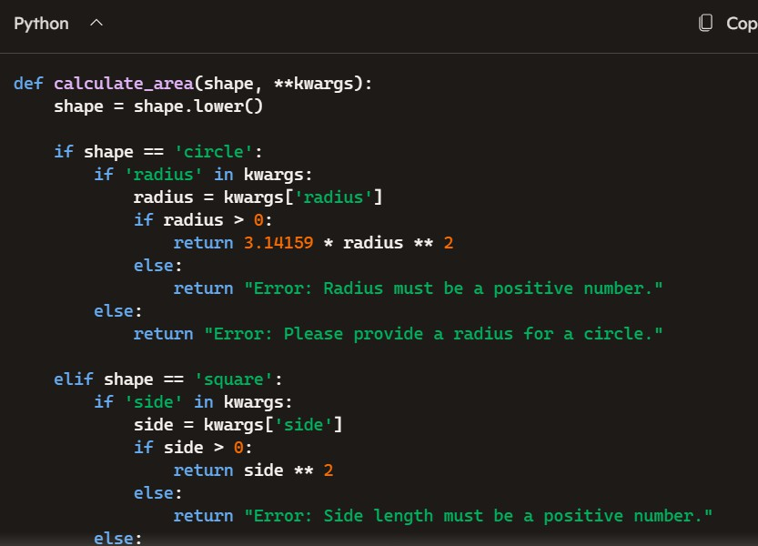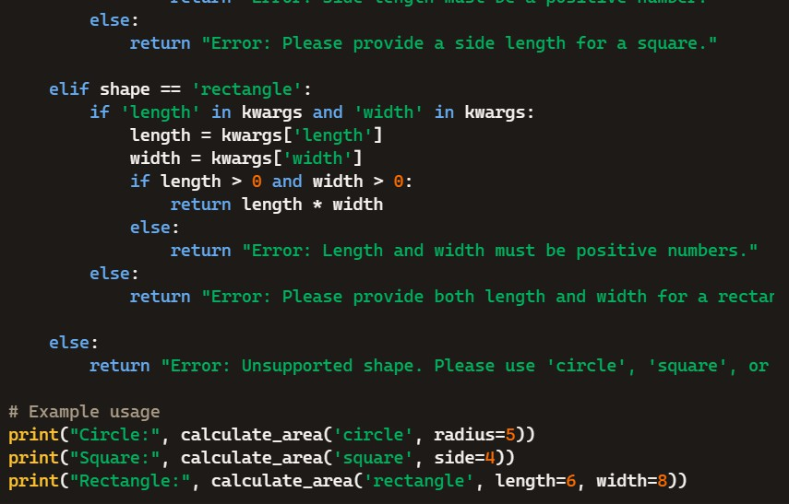

Output –

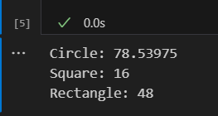

Copilot is again shorter and easy to understand compared to gemini and again the output is simpler in copilot

Task Description#4

* Install and configure Cursor AI. Use it to generate a Python function (e.g., sum of squares). prompt –

generate a Python function

Code –

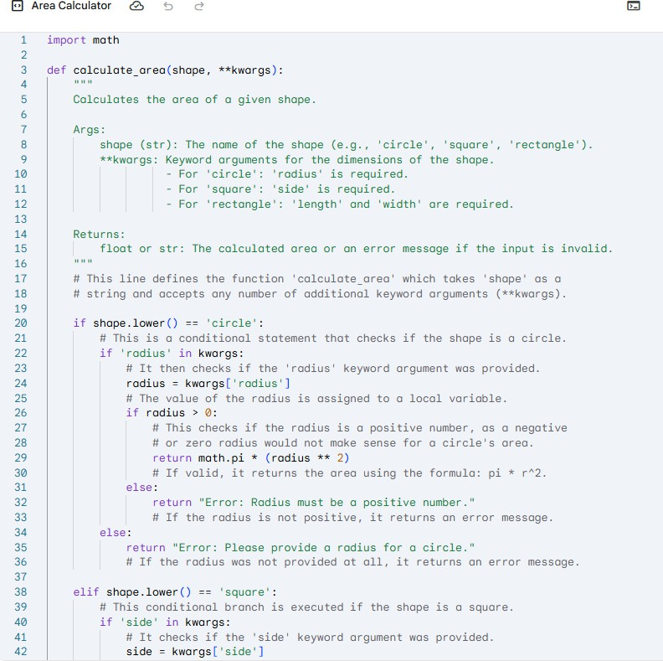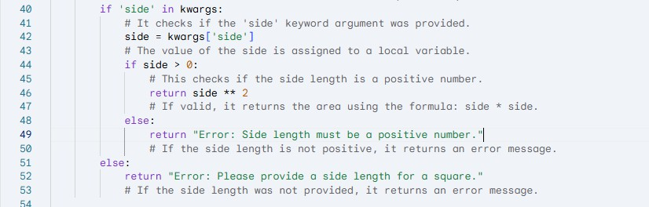

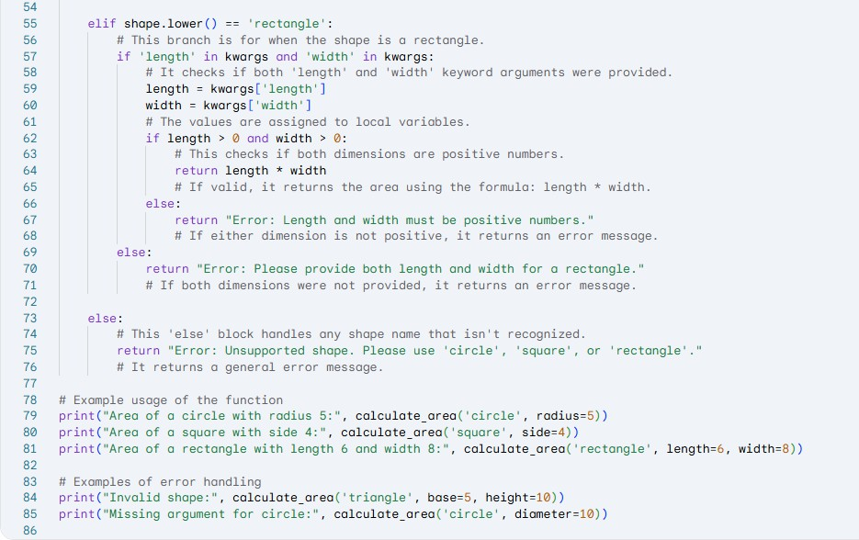

Output –

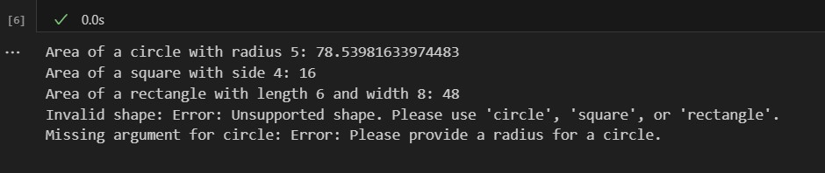

Task Description#5

* Student need to write code to calculate sum of add number and even numbers in the list.

prompt –

write code to calculate sum of add number and even numbers in the list.

Code –

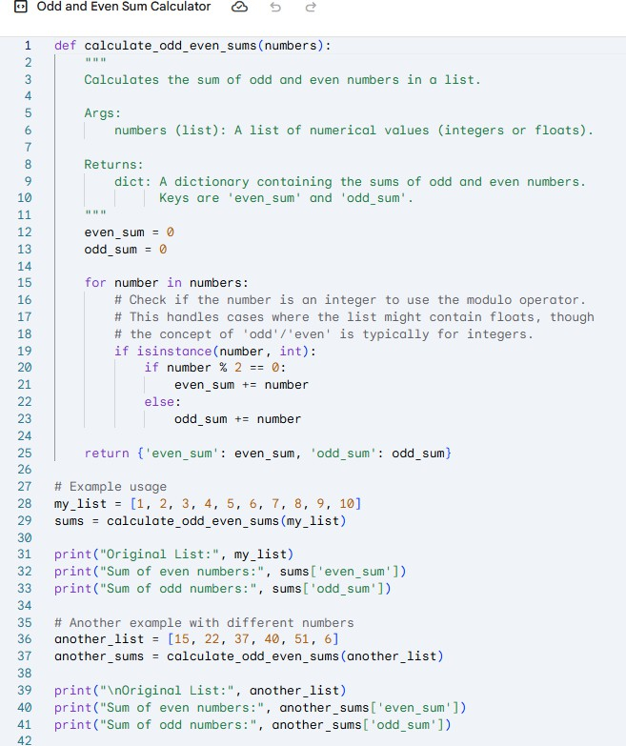

Output –

